Latent Diffusion Models

What does a generative model do?

It creates a very complex joint distribution of many variables(for example, for an image based generative model, it may learn the complex relations and distribution between all the pixel values), and samples data from it, to create or **generate** new data.

How does a Diffusion Model work?

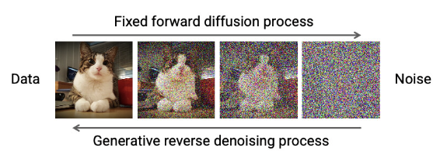

The forward process is where noise is randomly added to the data. This is a fixed process as we know how to generate noise in an image. However, the reverse process is much more complex, because we have to generate an image from noise. This is where a Neural Network comes in. It needs to learn some parameters about the images in order to generate an image.

Some important formulae: